**TELEGRAM**

**WEB APPLICATION**

**Telegram is a cloud based instant messaging and voice over IP service. The client apps are available for Android, iOS, Windows Phone, Windows, macOS and Linux. Users can send messages and exchange photos, videos, stickers, audio and files of any type.**

**1.After opening the website, the home page opens up where you can download this app for Desktop, MacOS, Android and see the benefits of the app.**

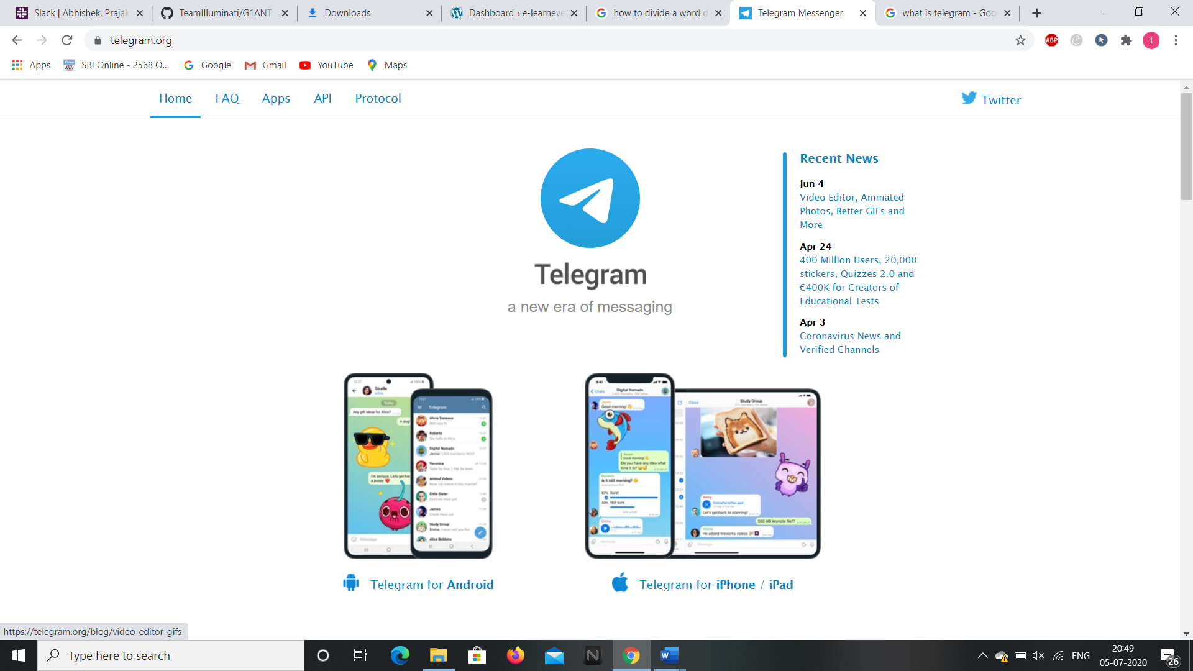

**2.Clicking the “FAQ” option at the left corner opens up the web page of Frequently Asked Questions on this app.**

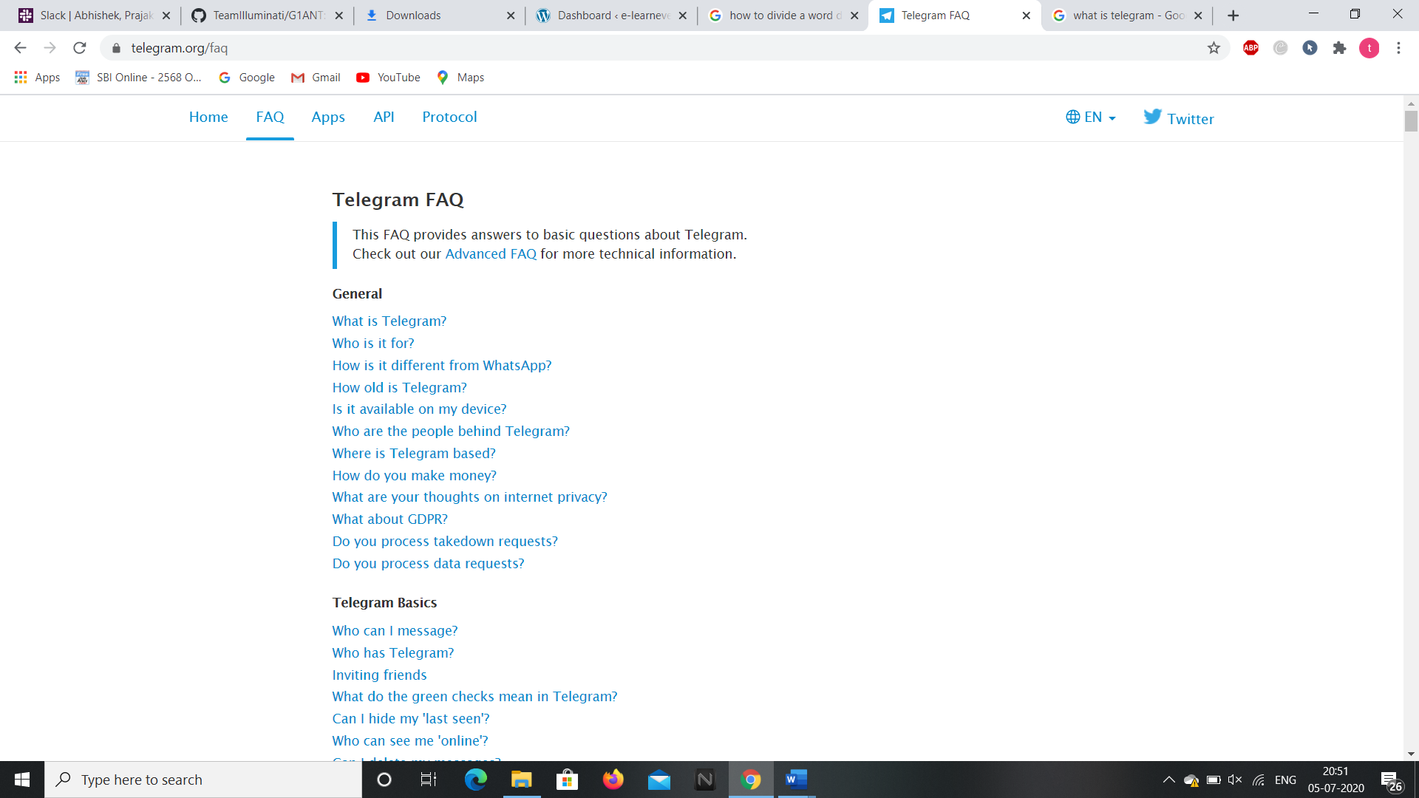

**3.Clicking on the “Apps” option right side to the FAQ option opens up the details of the app like source code and in which applications it can be downloaded.**

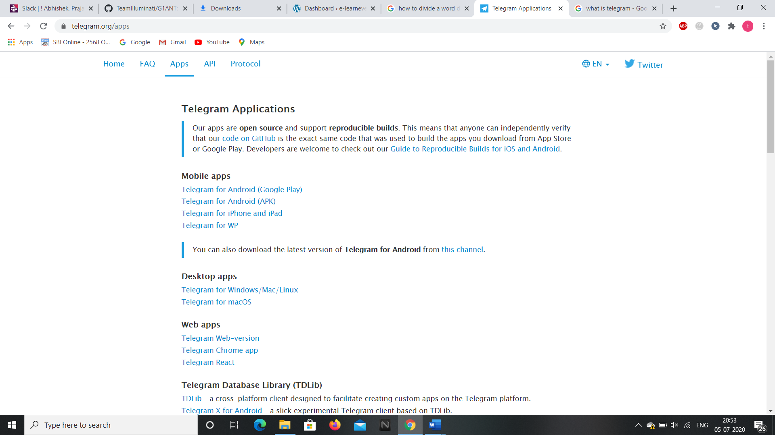

**4.Clicking on the “API” option we get access to the web page which gives details about bot APIs, Telegram APIs, TDLib etc.,**

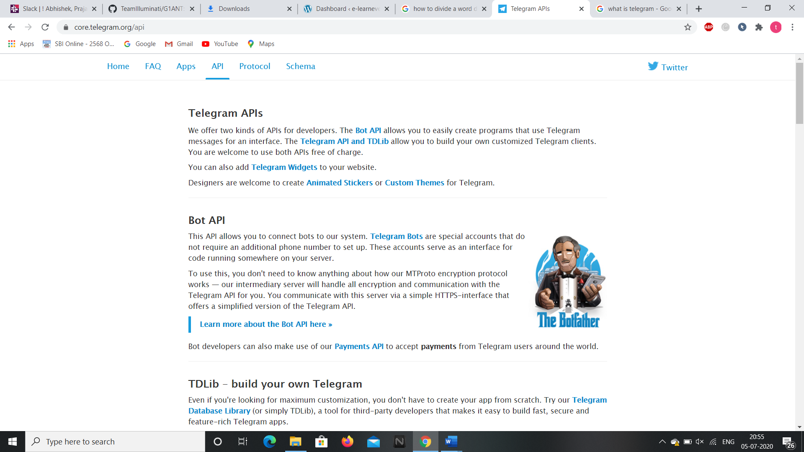

**5.Clicking on the “Protocol” option we get a brief description of the protocol and its summary in the web page that gets opened up.**

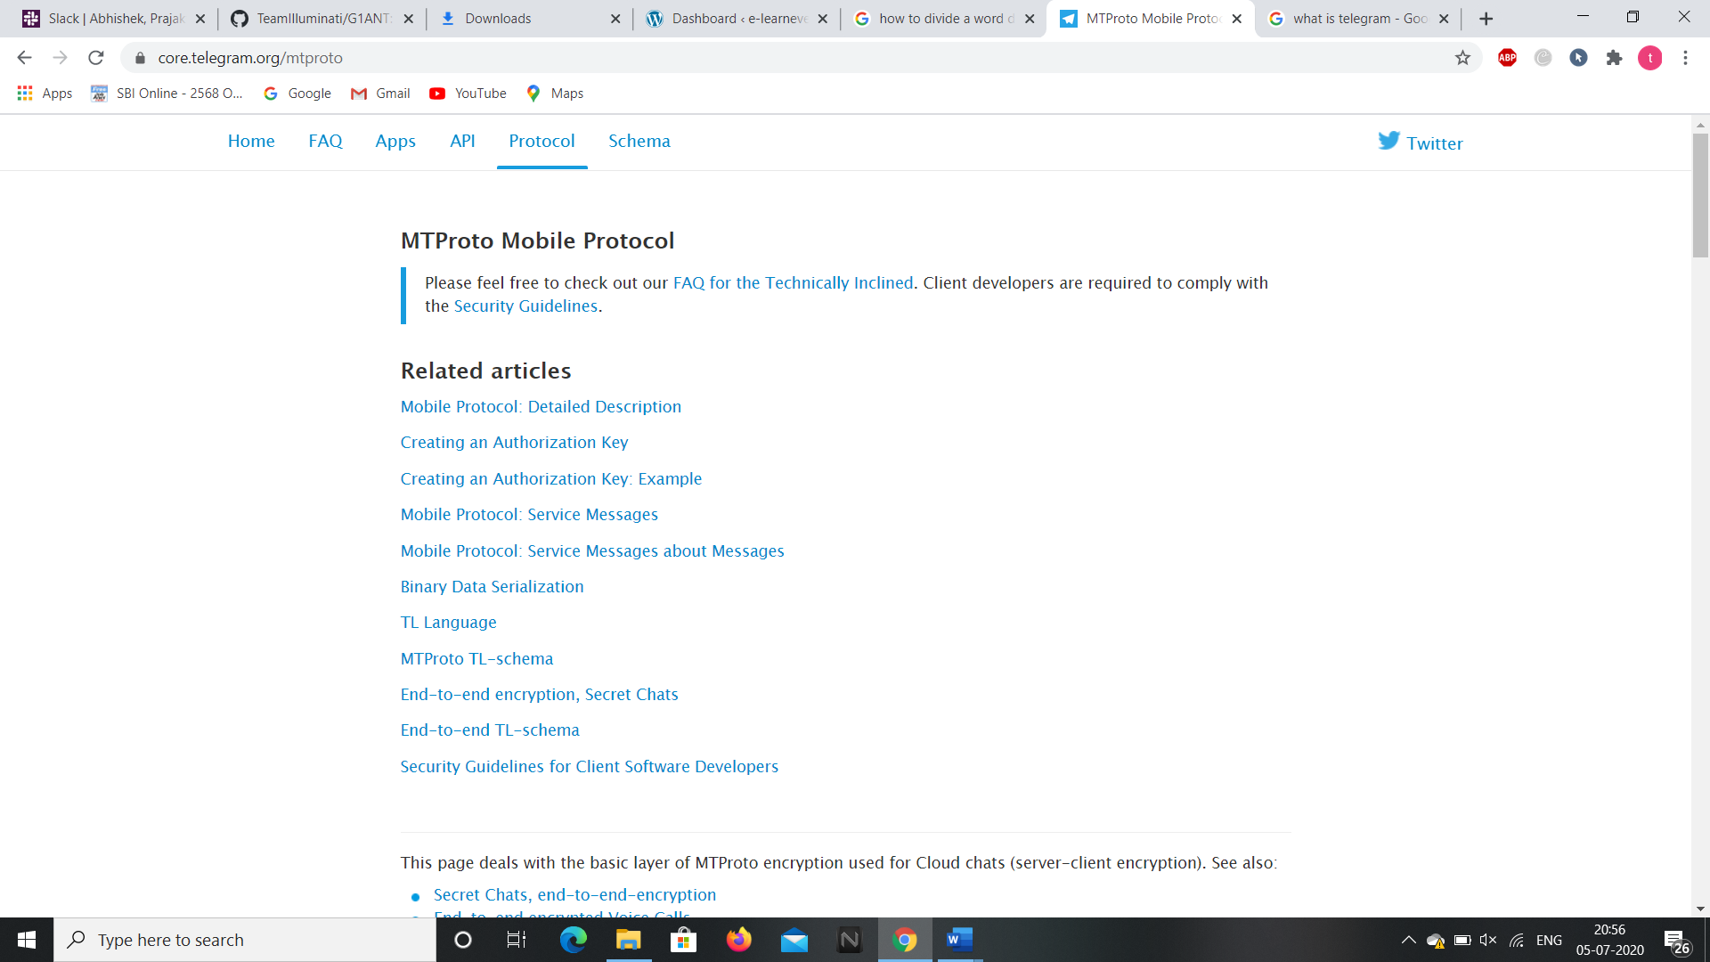

**6.Clicking on the “Schema” option opens up the web page which the schema or code used for the telegram.**

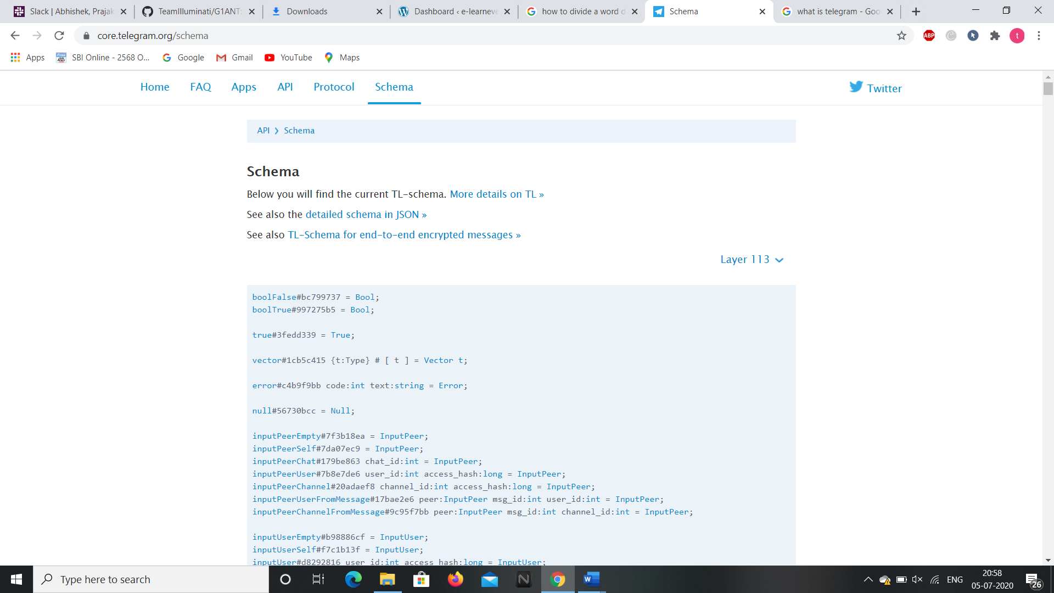

**So these are the contents present in the telegram website and we can access the webpage through selenium addon as well through G1ANT.**

**Now, let’s see the android application of it.**

**ANDROID APPLICATION**

**We can download the android application through “Google Play Store” and installing it in the Virtual Phone through Android Studio.**

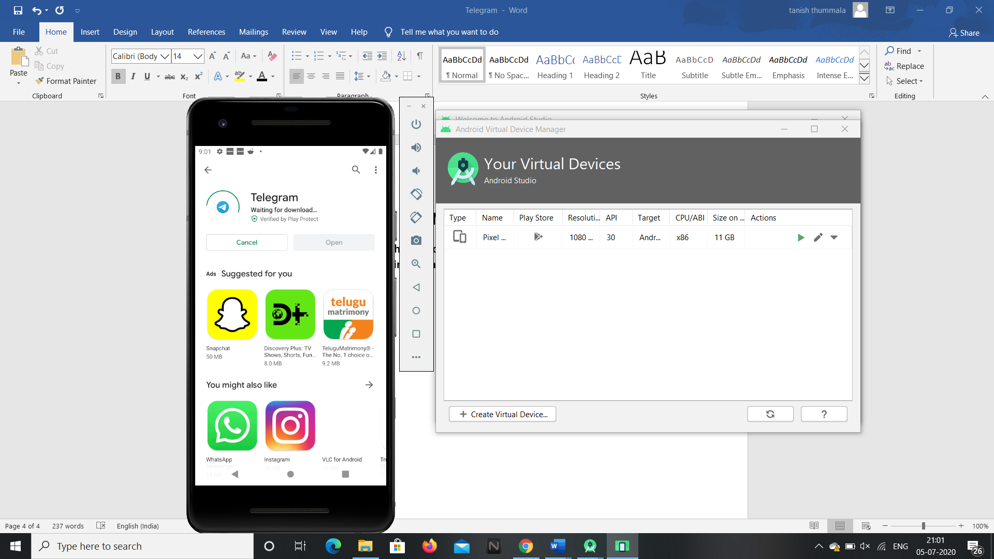

**1.After installing and opening the app, it asks our phone number and sends an OTP.**

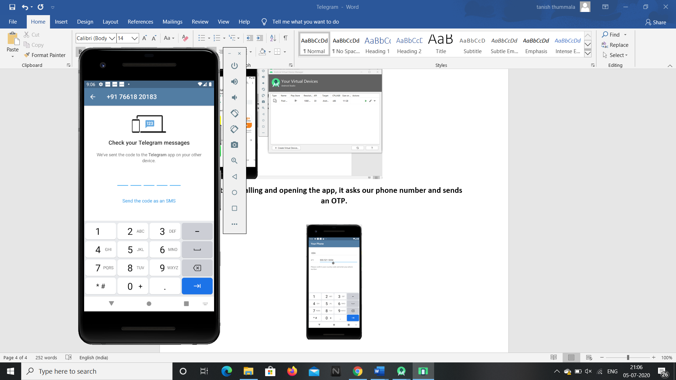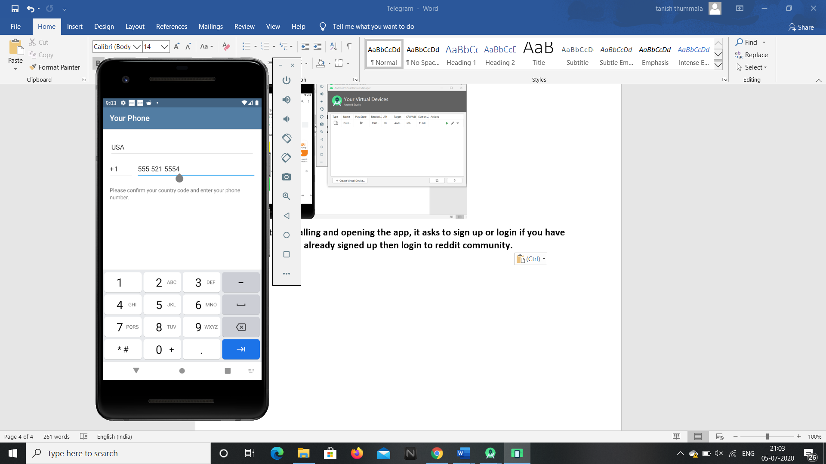

**2.Telegram gets opened and by selecting the triple box icon at the left corner we can get details of new group, new chats, saved messages and our profile details.**

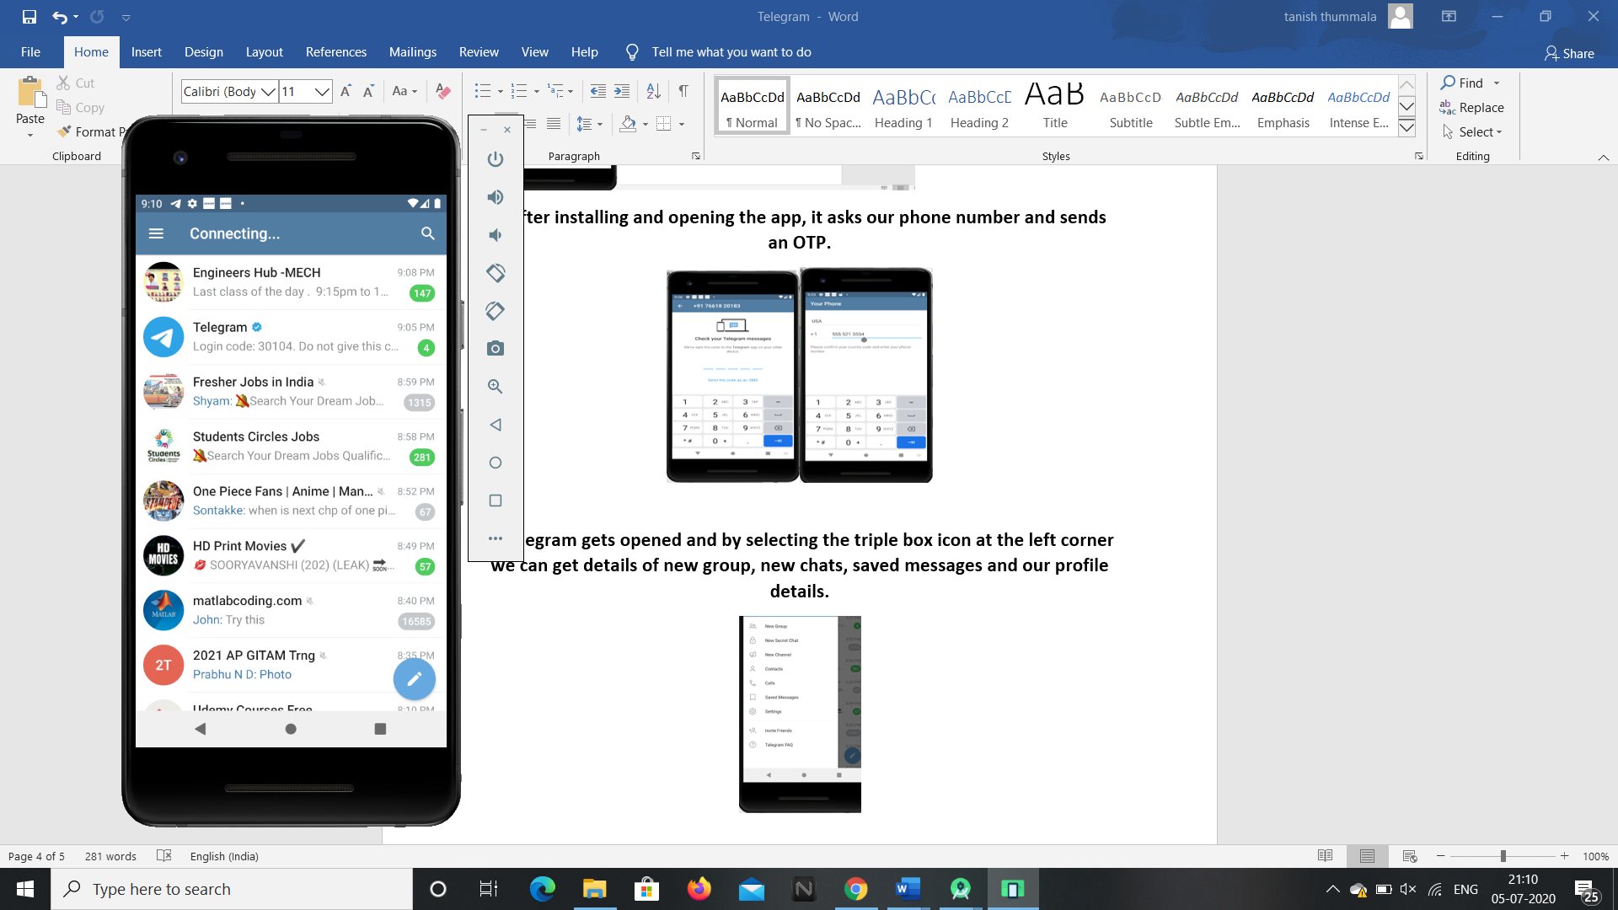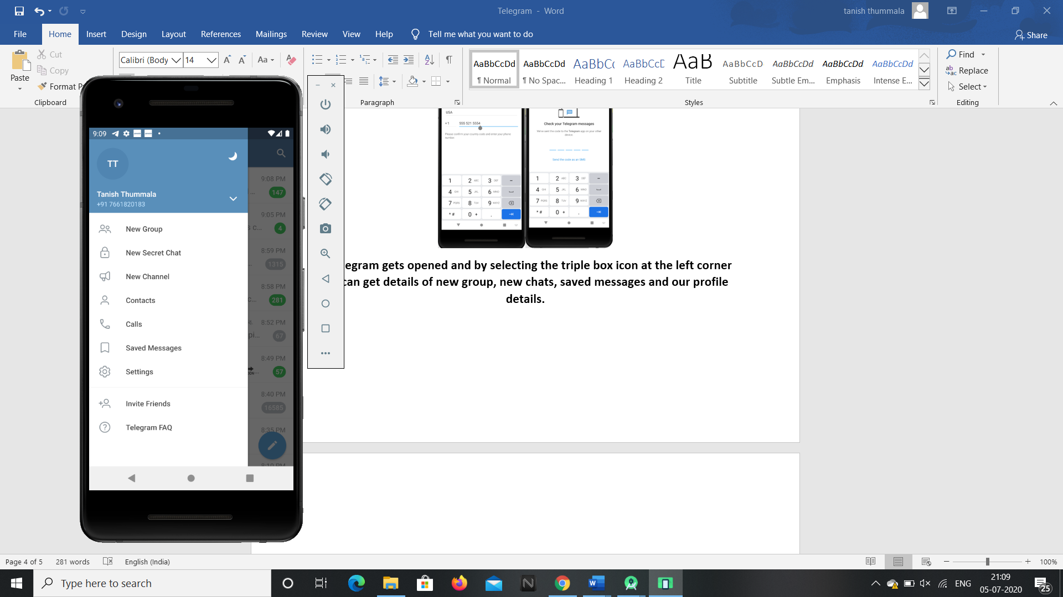

**3.Clicking the search icon at the top right corner will allow us to search for groups we want.**

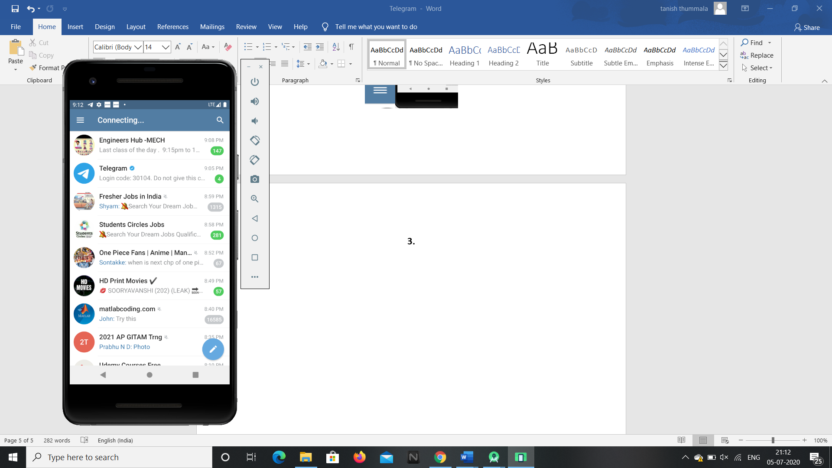

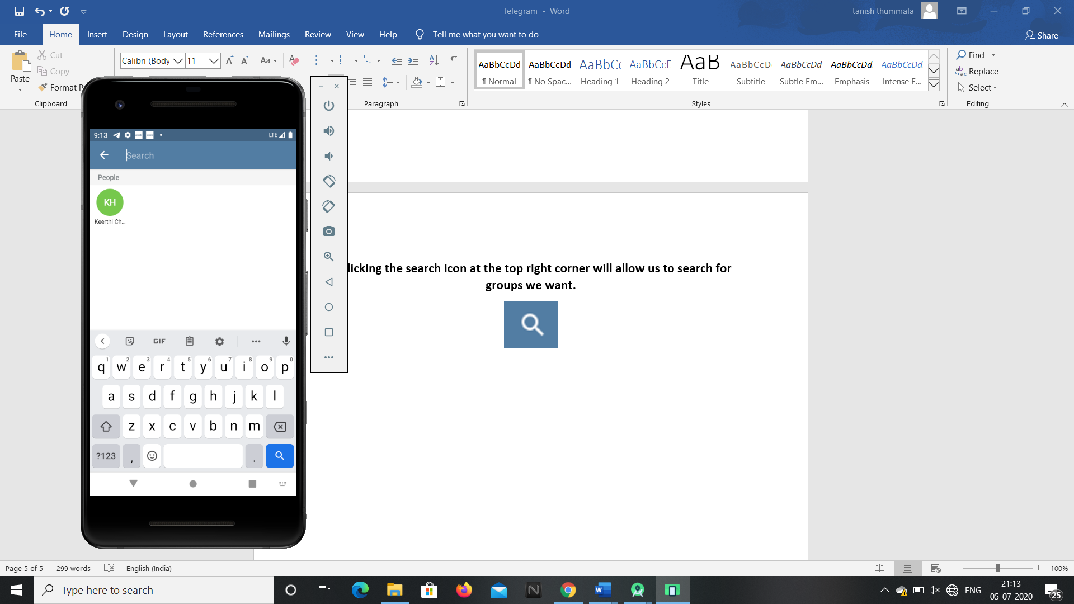

**4.Clicking on the edit option will allow the user to add contacts, create new groups, new secret chats etc.,**

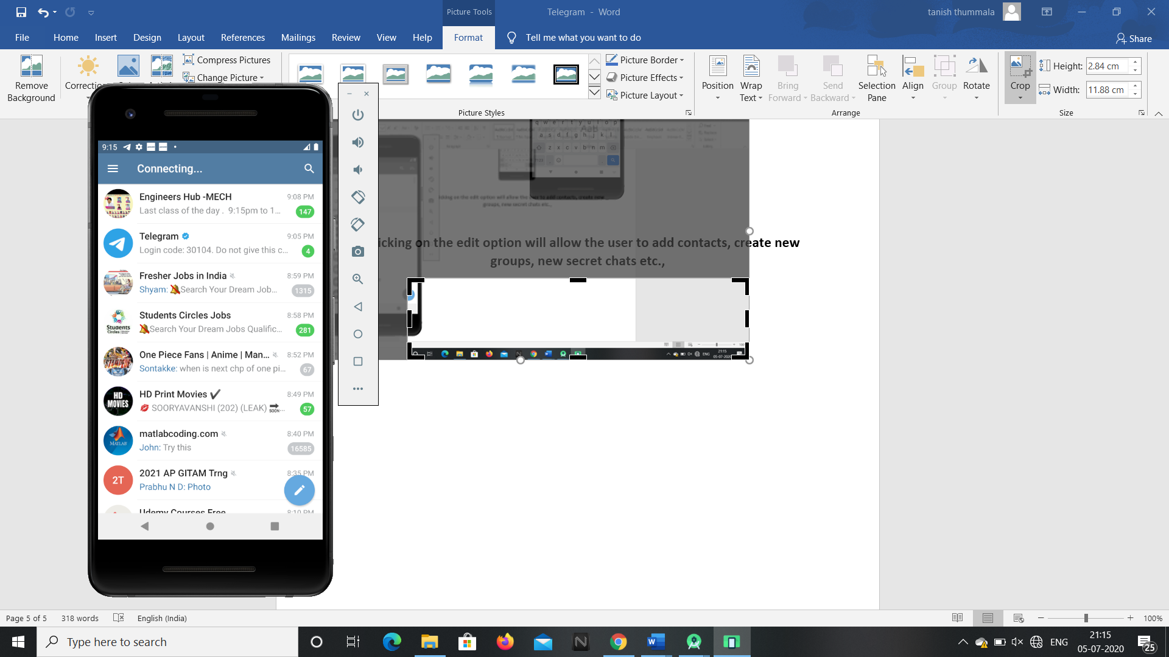

**So these are the features present in the telegram android application and these can be accessed by G1ANT Robot through Appium addon.**